Mathematical Modelling of Regulatory cascade in Psoriasis
Harishchander Anandaram¹, Daniel Alex Anand²
¹Centre for Excellence in Computational Engineering and Networking, Amrita Vishwa Vidyapeetham, Coimbatore, Tamil Nadu, India
²Department of Bioinformatics, Sathyabama Institute of Science Technology, Chennai, Tamil Nadu, India
Email ID: a_harishchander@cb.amrita.edu
Abstract
In the post-genomic era, mathematical modeling of regulatory cascades in gene-regulated networks in autoimmune diseases (AIDs) like Psoriasis is an uphill task to execute. Understanding gene-regulated networks in Pathogenesis is vital to identify the therapeutic biomarkers. Construction of a high-dimensional regulatory network and partitioning the specific regulatory region is the process of identification. Degree identification is the network parameter that is widely used in the process of identification of regulated regions. The tool Cytoscape is used for the construction of regulatory networks. Pharmacogenomic-based Micro-RNA regulation is the vital factor for the identification regulatory cascade. The pathway of the regulatory cascade is the initiation factor for Pathogenesis. Most of the regions in the regulatory cascade serve as prognostic, therapeutic, and diagnostic biomarkers. In Psoriasis, the myeloid dendritic cells produce a negative factor in interleukins' differential expression [1]. The interleukin gene IL36A was expressed differentially with a significant fold change in various studies [2]. The gene IL36A is associated with the protein IL23 and initiates signaling in dendritic cells to induce epidermal hyperplasia [3]. IL23, TNFα, IL17, CXC, and CCL20 were involved in releasing antimicrobial peptides (AMP) in the signaling process [4]. In total, 316 unique genes were selected to construct the regulatory network of Psoriasis. The majority of the obtained gene regulatory relationships (Gene-TFs-miRNA) were confirmed by various experimental studies published in the literature to demonstrate the validity-regulated genes in Psoriasis (Fig. 1A). SRF gene family (Fig. 1B) and the co-regulators serve as an additional biomarker and the relative regulator of Pathogenesis in Psoriasis based on cascade ranking and segmentation of the complete regulatory network with biological insight based validation along with the graph centrality principle of betweenness and coefficients. The cascade regulators (Table.1) are listed in the Table. Among various regulatory patterns, the flux balance analysis of regulatory network for the association of Cytokine Chemokine Receptor Pathway, the vital regulators were given in TABLE. I and the cascade of regulatory pathogenesis in Psoriasis initiated by the (a) SRC-> hsa-miR-20a-> MYOD1 and followed by (b) MAPK3-> hsa-miR-106a -> FOS and (c) EIF4E -> hsa-miR-125a -> CCND1.

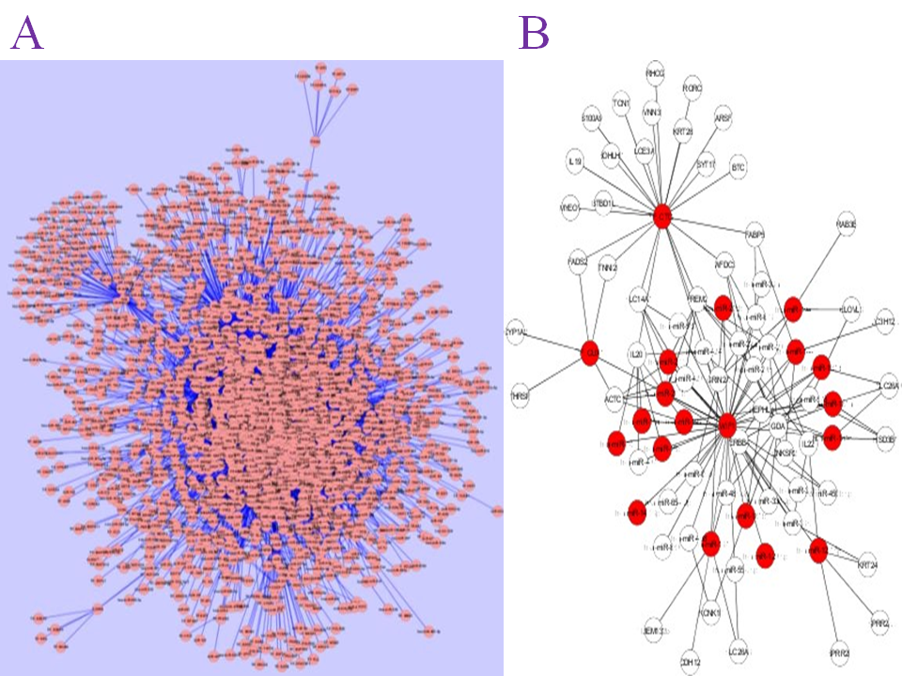
Fig.1. Complete Regulatory Network: A. Specific Regulatory Cascade: B.

After Performing the analysis of the process in Pathogenesis from basic biological processing of cellular functions concerning the transition of metabolites in components of Cellular signaling and biochemical pathways, specific markers in the regulatory cascade can be taken for further experimental studies. The regulatory cascade is initiated by the gene SRC.
Table 1. Vital Gene, Regulator and Cascade
Gene | Micro-RNA | Transcription  Factor | Regulatory Cascade
SRC | hsa-miR-20a | MYOD1 | SRC-> hsa-miR-20a-> MYOD1

References
[1] C. Aditi and S. Swapan, Clin. Epi., 10, P108 (2018)
[2] V. Agar, eLi.Mol. Bio., 4, E05 (2015).
[3] J. Alexander and C. Jan, Oxf. Dat. Bas., 2(1), 6 (2017).
[4] J. Alameda, Ce. Dea. Dis., 2, E208 (2011)

